Outer Diameter of a Cylinder
# Source: AI Source: Provided by: [Data Path: Persons Table -> ID Column: 1, Name_En Column: Motasem Essam] -> From: [ChatGPT] on [7/25/2026]
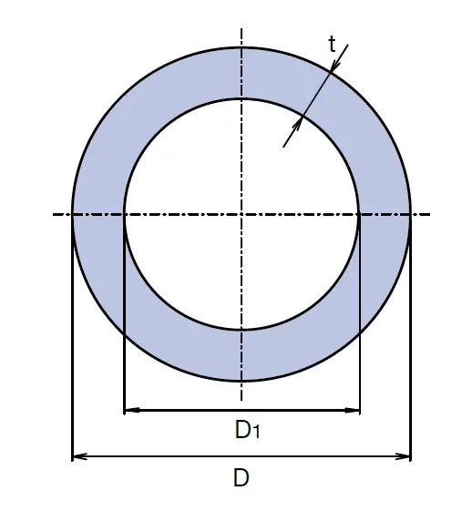
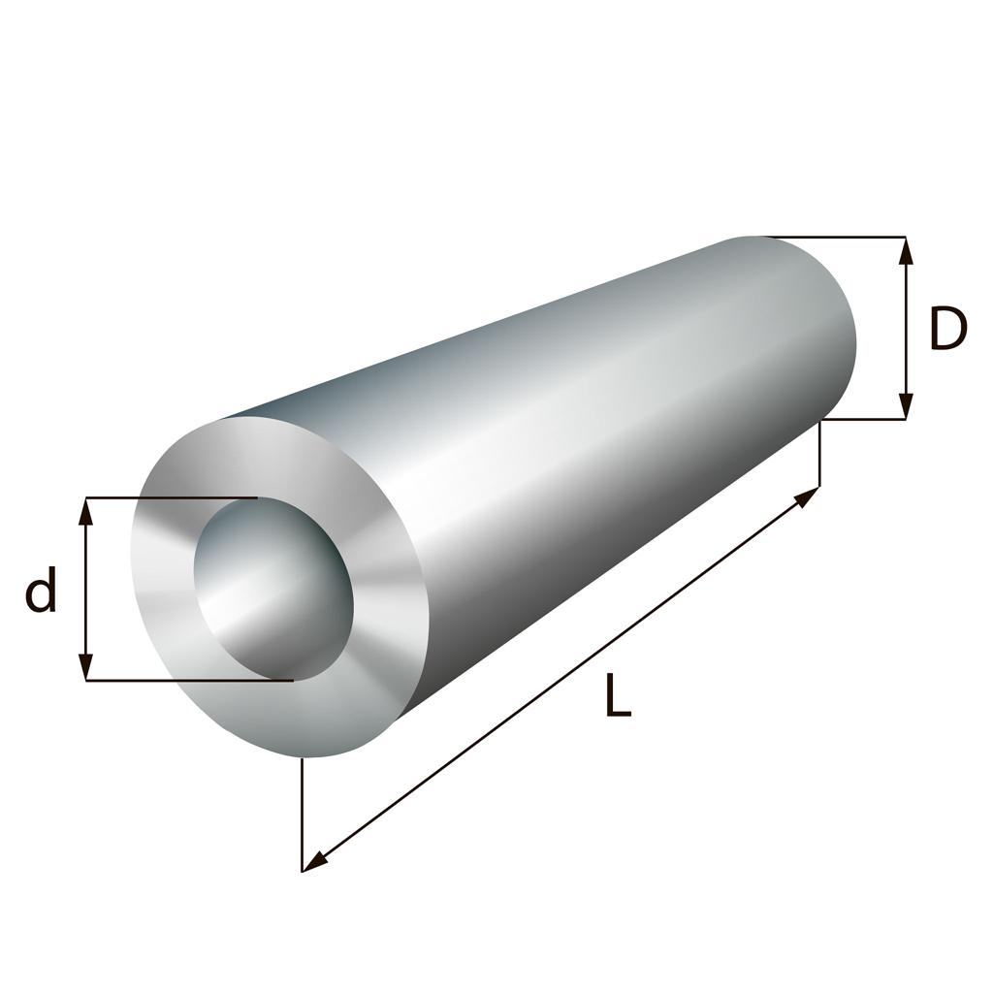
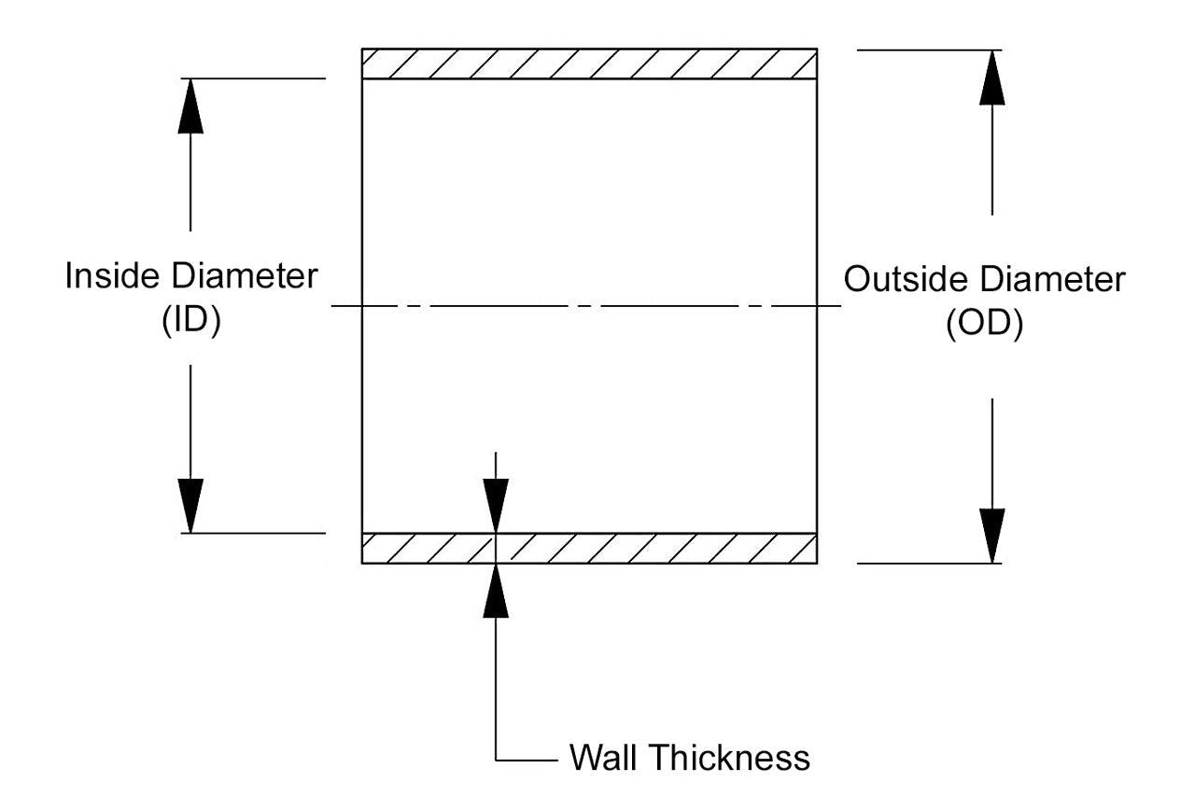

Definition
# Source: AI Source: Provided by: [Data Path: Persons Table -> ID Column: 1, Name_En Column: Motasem Essam] -> From: [ChatGPT] on [7/25/2026]
The outer diameter of a cylinder is the distance across its external circular boundary, measured along a straight line passing through the center of the circular cross-section.
It is commonly represented by $D_{o}$ or $D$. For a hollow cylinder, the outer diameter measures the full width from one outside edge to the opposite outside edge, including the material and the hollow interior.
For a standard cylinder with circular bases, the outer diameter is twice the outer radius.
$$\boxed{D_{o}=2R}$$

Simple Definition
# Source: AI Source: Provided by: [Data Path: Persons Table -> ID Column: 1, Name_En Column: Motasem Essam] -> From: [ChatGPT] on [7/25/2026]
The outer diameter is the full distance across the outside of a cylinder through its center.

Geometric Representation
# Source: AI Source: Provided by: [Data Path: Persons Table -> ID Column: 1, Name_En Column: Motasem Essam] -> From: [ChatGPT] on [7/25/2026]
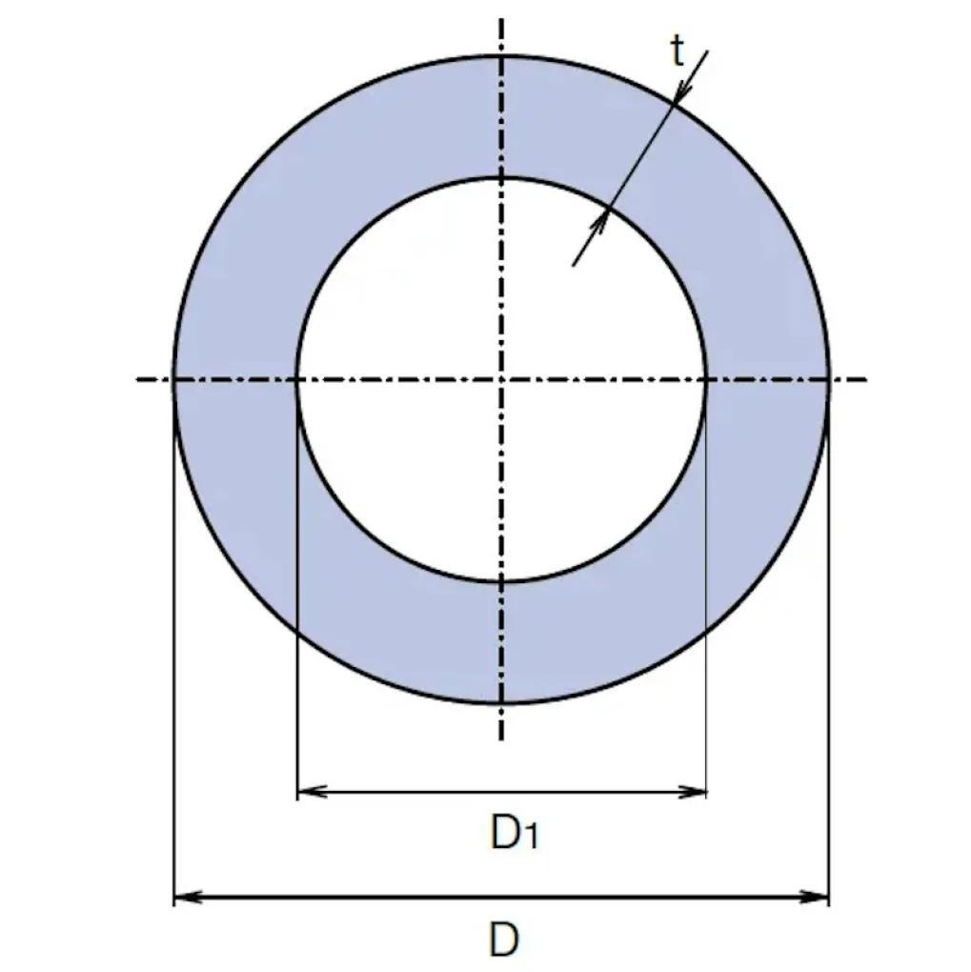
The outer diameter is associated with the following geometric components:
- Outer circular boundary: the external edge of the circular cross-section.
- Center: the center of the circular base or cross-section.
- Outer radius ($R$): the distance from the center to the outside edge.
- Outer diameter ($D_{o}$): the distance between opposite points on the external boundary through the center.
- Inner diameter ($D_{i}$): the diameter of the hollow opening, if the cylinder is hollow.
The outer diameter includes the hollow region in the overall width measurement; it is not the diameter of the opening alone.

Mathematical Formulas

Outer Diameter from Outer Radius
# Source: AI Source: Provided by: [Data Path: Persons Table -> ID Column: 1, Name_En Column: Motasem Essam] -> From: [ChatGPT] on [7/25/2026]
$$\boxed{D_{o}=2R}$$

Outer Radius from Outer Diameter
# Source: AI Source: Provided by: [Data Path: Persons Table -> ID Column: 1, Name_En Column: Motasem Essam] -> From: [ChatGPT] on [7/25/2026]
$$\boxed{R=\frac{D_{o}}{2}}$$

Outer Circumference
# Source: AI Source: Provided by: [Data Path: Persons Table -> ID Column: 1, Name_En Column: Motasem Essam] -> From: [ChatGPT] on [7/25/2026]
$$C_{o}=πD_{o}$$
Therefore,
$$\boxed{D_{o}=\frac{C_{o}}{π}}$$

Outer Circular Area
# Source: AI Source: Provided by: [Data Path: Persons Table -> ID Column: 1, Name_En Column: Motasem Essam] -> From: [ChatGPT] on [7/25/2026]
The area enclosed by the outer circular boundary is:
$$A_{o}=πR^{2}$$
Using $R=D_{o}/2$:
$$\boxed{A_{o}=\frac{πD_{o}^{2}}{4}}$$
For a hollow cylinder, this is the area of the entire outer circle, not the area of the material alone.

Outer Diameter from Inner Diameter and Wall Thickness
# Source: AI Source: Provided by: [Data Path: Persons Table -> ID Column: 1, Name_En Column: Motasem Essam] -> From: [ChatGPT] on [7/25/2026]
For a hollow cylinder with uniform wall thickness $t$:
$$R=r_{i}+t$$
Consequently,
$$\boxed{D_{o}=D_{i}+2t}$$
where $D_{i}$ is the inner diameter.

Worked Examples
# Source: AI Source: Provided by: [Data Path: Persons Table -> ID Column: 1, Name_En Column: Motasem Essam] -> From: [ChatGPT] on [7/25/2026]
Example 1: Finding the outer diameter from the radius
Given: Outer radius $R=9\text{ cm}$.
Solution:
$$D_{o}=2R=2\left(9\right)$$
Answer: $\boxed{D_{o}=18\text{ cm}}$
Example 2: Finding the outer diameter from the inner diameter
Given:
- Inner diameter: $D_{i}=24\text{ mm}$
- Wall thickness: $t=3\text{ mm}$
Solution:
$$D_{o}=D_{i}+2t$$
$$D_{o}=24+2\left(3\right)$$
Answer: $\boxed{D_{o}=30\text{ mm}}$
Example 3: Finding the outer diameter from circumference
Given: Outer circumference $C_{o}=40π\text{ cm}$.
Solution:
$$D_{o}=\frac{C_{o}}{π}=\frac{40π}{π}$$
Answer: $\boxed{D_{o}=40\text{ cm}}$
Example 4: Finding the outer circular area
Given: Outer diameter $D_{o}=12\text{ cm}$.
Solution:
$$A_{o}=\frac{πD_{o}^{2}}{4}=\frac{π{\left(12\right)}^{2}}{4}$$
Answer: $\boxed{A_{o}=36π{\text{ cm}}^{2}}$, approximately $113.10{\text{ cm}}^{2}$.

Key Characteristics
# Source: AI Source: Provided by: [Data Path: Persons Table -> ID Column: 1, Name_En Column: Motasem Essam] -> From: [ChatGPT] on [7/25/2026]
- The outer diameter is a linear measurement.
- It passes through the center of the circular cross-section.
- It equals twice the outer radius.
- It is greater than the inner diameter of a hollow cylinder with positive wall thickness.
- It determines the overall external width of a cylindrical component.
- For a hollow cylinder, the outer diameter alone does not determine the opening size or wall thickness.

Comparison with Related Measurements
# Source: AI Source: Provided by: [Data Path: Persons Table -> ID Column: 1, Name_En Column: Motasem Essam] -> From: [ChatGPT] on [7/25/2026]
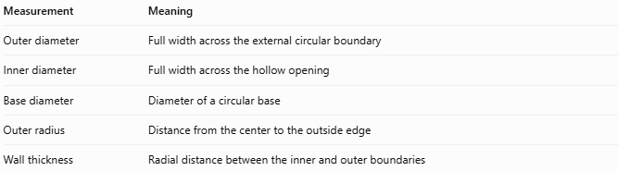
Measurement | Meaning
Outer diameter | Full width across the external circular boundary
Inner diameter | Full width across the hollow opening
Base diameter | Diameter of a circular base
Outer radius | Distance from the center to the outside edge
Wall thickness | Radial distance between the inner and outer boundaries
Important distinction: In a solid cylinder, the ordinary base diameter is also its external diameter. In a hollow cylinder, the outer diameter and inner diameter describe different circular boundaries.

Applications
# Source: AI Source: Provided by: [Data Path: Persons Table -> ID Column: 1, Name_En Column: Motasem Essam] -> From: [ChatGPT] on [7/25/2026]
- Pipe manufacturing: specifies the overall external size of pipes and tubes.
- Mechanical engineering: determines component fit and clearance.
- Construction: measures the external dimensions of cylindrical supports.
- Plumbing: helps select compatible fittings and clamps.
- Geometry: supports calculations involving circumference, circular area, and cylindrical dimensions.

Key Points
# Source: AI Source: Provided by: [Data Path: Persons Table -> ID Column: 1, Name_En Column: Motasem Essam] -> From: [ChatGPT] on [7/25/2026]
- Symbol: $D_{o}$
- From outer radius: $D_{o}=2R$
- From outer circumference: $D_{o}=C_{o}/π$
- From inner diameter and thickness: $D_{o}=D_{i}+2t$
- Outer circular area: $A_{o}=πD_{o}^{2}/4$

Conclusion
# Source: AI Source: Provided by: [Data Path: Persons Table -> ID Column: 1, Name_En Column: Motasem Essam] -> From: [ChatGPT] on [7/25/2026]
The outer diameter measures the full width across the outside of a cylinder through its center. It is essential for describing external dimensions and is particularly useful for hollow cylinders, where it must be distinguished from the inner diameter.

